**LAB#08**

**OBJECT: Construct a truth table for y = $x^{2}$ where x is 3-bit input variable. Design a k.map for the truth table, minimize it and design circuit for minimize expression.**

**APPARATUS:**

* 74LS08
* 74LS04
* 74LS32
* 74LS86
* Bread Board
* Connecting Wires
* LED
* DC Supply

**SYMBOLS:**

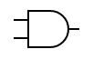

AND GATE

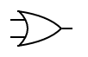

OR GATE



NOT GATE

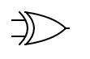

XOR GATE

**TRUTH TABLE:**

|  |  |  |  |  |  |  |  |  |  |  |
| --- | --- | --- | --- | --- | --- | --- | --- | --- | --- | --- |
| **X** | **A** | **B** | **C** | **Y0** | **Y1** | **Y2** | **Y3** | **Y4** | **Y5** | **Y** |
| 0 | 0 | 0 | 0 | 0 | 0 | 0 | 0 | 0 | 0 | 0 |
| 1 | 0 | 0 | 1 | 0 | 0 | 0 | 0 | 0 | 1 | 1 |
| 2 | 0 | 1 | 0 | 0 | 0 | 0 | 1 | 0 | 0 | 4 |
| 3 | 0 | 1 | 1 | 0 | 0 | 1 | 0 | 0 | 1 | 9 |
| 4 | 1 | 0 | 0 | 0 | 1 | 0 | 0 | 0 | 0 | 16 |
| 5 | 1 | 0 | 1 | 0 | 1 | 1 | 0 | 0 | 1 | 25 |
| 6 | 1 | 1 | 0 | 1 | 0 | 0 | 1 | 0 | 0 | 36 |
| 7 | 1 | 1 | 1 | 1 | 1 | 0 | 0 | 0 | 1 | 49 |

**KARNAUGH MAP:**

K-MAP FOR Y0:

|  |  |  |
| --- | --- | --- |
|  | $$\overline{C}$$ | $$C$$ |
| $$\overline{A }\overline{B}$$ | 0 | 0 |
| $$\overline{A }B$$ | 0 | 0 |
| $$AB$$ | 1 | 1 |
| $$A\overline{B}$$ | 0 | 0 |

**Y0= AB**

K-MAP FOR Y1:

|  |  |  |
| --- | --- | --- |
|  | $$\overline{C}$$ | $$C$$ |
| $$\overline{A }\overline{B}$$ | 0 | 0 |
| $$\overline{A }B$$ | 0 | 0 |
| $$AB$$ | 0 | 1 |
| $$A\overline{B}$$ | 1 | 1 |

**Y1= AC + A $\overline{B}$ = A(C+ $\overline{B}$)**

K-MAP FOR Y2:

|  |  |  |
| --- | --- | --- |
|  | $$\overline{C}$$ | $$C$$ |
| $$\overline{A }\overline{B}$$ | 0 | 0 |
| $$\overline{A }B$$ | 0 | 1 |
| $$AB$$ | 0 | 0 |
| $$A\overline{B}$$ | 0 | 1 |

**Y2= $\overline{A}$ BC + A $\overline{B}$ C = C($\overline{A}$ B + A $\overline{B}$) = C(A⊕B)**

K-MAP FOR Y3:

|  |  |  |
| --- | --- | --- |
|  | $$\overline{C}$$ | $$C$$ |
| $$\overline{A }\overline{B}$$ | 0 | 0 |
| $$\overline{A }B$$ | 1 | 0 |
| $$AB$$ | 1 | 0 |
| $$A\overline{B}$$ | 0 | 0 |

**Y3= B $\overline{C}$**

K-MAP FOR Y4:

|  |  |  |
| --- | --- | --- |
|  | $$\overline{C}$$ | $$C$$ |
| $$\overline{A }\overline{B}$$ | 0 | 0 |
| $$\overline{A }B$$ | 0 | 0 |
| $$AB$$ | 0 | 0 |
| $$A\overline{B}$$ | 0 | 0 |

**Y4=0**

K-MAP FOR Y5:

|  |  |  |
| --- | --- | --- |
|  | $$\overline{C}$$ | $$C$$ |
| $$\overline{A }\overline{B}$$ | 0 | 1 |
| $$\overline{A }B$$ | 0 | 1 |
| $$AB$$ | 0 | 1 |
| $$A\overline{B}$$ | 0 | 1 |

**Y5= C**

**CIRCUIT DESIGN:**

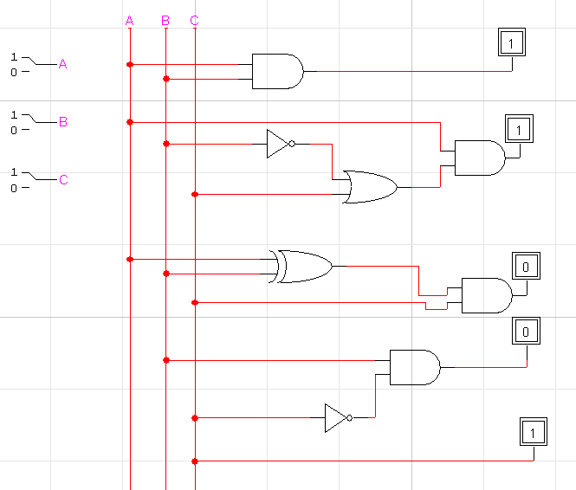

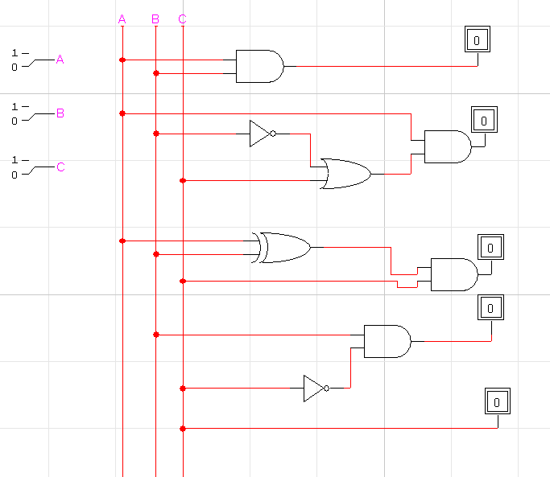

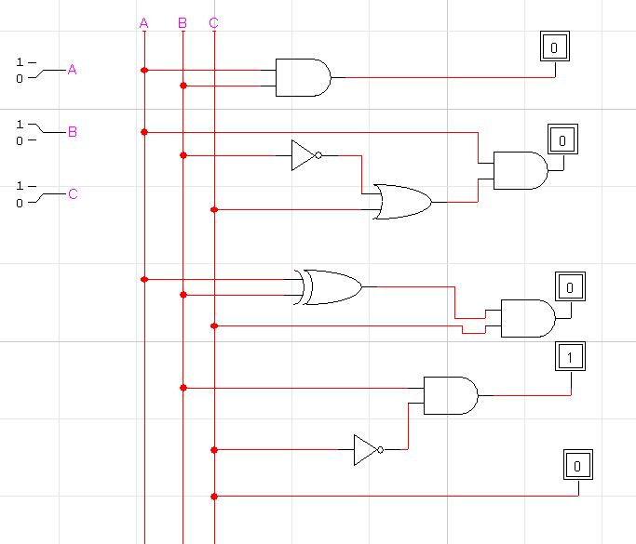

**CONCLUSION:**

The circuit is working according to the truth table.